|  |  |  |
| --- | --- | --- |
| 版本R33： | 合併文件：矽元件熱蒸鍍機(Thermal)鍍金作業標準(SEG-5-029)  新增1.2更換蒸鍍清洗藥水時作業及記錄方法  新增1.4背金清洗藥水調配及記錄方式  刪除1.4.3 IPA清洗方式  新增1.5背金蒸鍍前清洗方式  新增1.7背金蒸鍍檔片清洗方式  新增1.8晶片置於轉盤上之注意事項  新增1.10蒸鍍機內容Al#1之程式AlSi-25K#36、AlSi-25K#37  修改1.10蒸鍍程式Al-30K規格為30± 5KA  刪除1.12.4抽氣時間記錄標準  新增1.12.6背金蒸鍍載玻片檢驗方式  新增1.12.7背金SPC 管制項目  新增1.14背金部分產品異常檢驗項目及異常開立原則  新增1.16每鍋蒸鍍後需試刮背金2片確認是否有脫金現象  新增1.17 AUK/AUE產品背金顏色不均判定方式  修改2.2.4.1金屬錠更換頻率  新增2.2.11新增遮板開關檢查  新增5.9矽元件各班庫存金屬清點紀錄(FM090167)  新增5.10溶液更換紀錄表(FMP020009)  新增5.11矽元件3樓無塵各班每日金屬使用量表(FMP020098) | 發行日20240202 |
| 版本R34： | 刪除1.10.1 E-gun蒸鍍機台程式對照表中產品內容  修改1.10.1E-gun蒸鍍機台程式對照表中Al#1的AlSi-35K及AlSi-25K recipe代號  修改1.10.5 (Al#2、Al#3)E-gun坩鍋位置配置表格  新增1.12.3蒸鍍作業前遮板開啟檢查 | 發行日20240321 |
| 版本R35 | 修改1.2文字錯誤  修改1.10.1文字錯誤  新增1.12.1 Al靶材注意事項  刪除1.13鉻錠更換頻率，並整合至2.2.4.1  新增1.12.6抽氣時間記錄標準  修改1.12.8蒸鍍區使用紀錄表填寫內容  刪除1.12.14蒸鍍表單紀錄內容  刪除1.11.3 Ti、Ni內容並整合至2.2.4.1  新增2.2.4.1金屬更換頻率表  新增2.2.4.2靶材長時間未作業處理方式  修改2.2.6.4工件噴砂出廠及進廠時，改為請廠商提供明細  刪除4.5蒸鍍機噴砂收送記錄表 (FMP020088)  刪除4.6 3樓無塵E-gun蒸鍍機鉻錠更換紀錄表 (FMP020097)  刪除4.7 3F蒸鍍區Ti、Ni、Ag紀錄表 (FMP020099)  新增4.9金屬更換紀錄表(FMP020105) | 發行日20240806 |
| 版本R36 | 新增1.3.2 Au金屬清洗手法  新增1.8.1 Dummy依產品前清洗方式清洗  修改1.10.1表格Cr-200Å/Au-600Å厚度規格為>0.8KÅ  修改1.12.8蒸鍍紀錄表單紀錄事項  新增4.10 蒸鍍擋片清洗記錄表(FMP020077) | 發行日20240909 |
| 版本R37 | 新增1.10.1表格中備註金屬添加說明  修改1.10.1表格Al-25K金屬用量從9 ±0.2 g修正為9.2 ±0.2 g  刪除1.11 E-gun蒸鍍金屬用量表格 | 發行日20240923 |
| 版本R38 | 新增1.10.1表格Ni-2K #43及Ni-5K/Au-2K #2#4參數  修改1.10.1表格中金屬添加用量、薄膜厚度 |  |

1. 操作步驟Evaporation procedure：
   1. 正面蒸鍍流程 Front side deposition process：
   2. 晶片清洗  
      參照 SEG-5-043矽元件Detector酸洗蝕刻作業標準  
      Referring SEG-5-043 Silicon Device Detector acid etching operating standards.  
      \*旋乾後，必須確認晶面無水殘留，才可進蒸鍍機。

Evaporation machine is not allowed wafer remain water residual.   
以氧化層厚度為7000~9000Å (F7-1/F7-2 105IO800)，成長在監控片(SBL1-3044 R=1~50 ohm-cm)上。  
Use furnace tube (F7-1/F7-2 105IO800) growing oxide layer, thickness=7000~9000 Å,  
top on control wafer (SBL1-3044 R=1~50 ohm-cm).  
各班於換藥水後，同產品作業時搖晃製具蝕刻監控片1分鐘，進行五點量測，將蝕刻率及作業累積片數記錄於表單 FMS10402並紀錄至SPC表格當中；若當日無配製的清洗藥水則不需特地進行量測。  
Every shift all follow : After change HF, let control wafer etching(wash) 1min, then measure 5 points to record etching rate and pcs number on the table FMS10402, and fill in the SPC form; If unused HF that day, don’t need measurement specially.  
兩點超出規格不需開立異常，但須通知工程確認

If 2 points out of the range, no exception is required, but the engineering confirmation must be notified.  
蒸鍍前清洗HF(50:1)蝕刻率為50~85 Å/min，HF(100:1)蝕刻率為25~50 Å/min  
The HF(50:1) etching rate is 50~85 Å/min, HF(100:1) etching rate is 25~50 Å/min  
同一清洗槽皆固定重複使用同一監控片以確保數據穩定，若監控片厚度<1500 Å則更換新監控片。  
The same one wash tank use the same control wafer repeated, if the oxide layer thickness<1500Å, change the new control wafer.  
量測前請先校準ST2000，而量測試片五點量測值時以平邊朝上依序為中(1C)、下(2D)、左(3L)、上(4U)、右(5R)，2~5點的位置約為晶片邊緣往內1公分±0.5公分  
Please calibrate the ST2000 before measurement, and when record table the five-point measurement value is with the flat side toward up in sequence of middle(1C)、down(2D)、left(3L)、up(4U)、right(5R), 2~5 points location at around the edge of the wafer inwards 1cm±0.5cm.

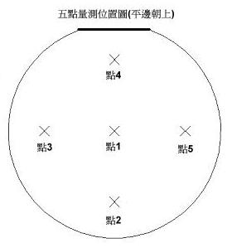

* 1. 蒸鍍金屬(AL)清洗Metal Source(AL) washing：
     1. Slug金屬錠(AL)清洗**步驟如下：**The steps of slug(AL) ingot washing procedure as follow:
        1. IPA浸泡5±1分鐘(邊泡邊攪拌)

Immerse in IPA for 5±1min (with stirring).

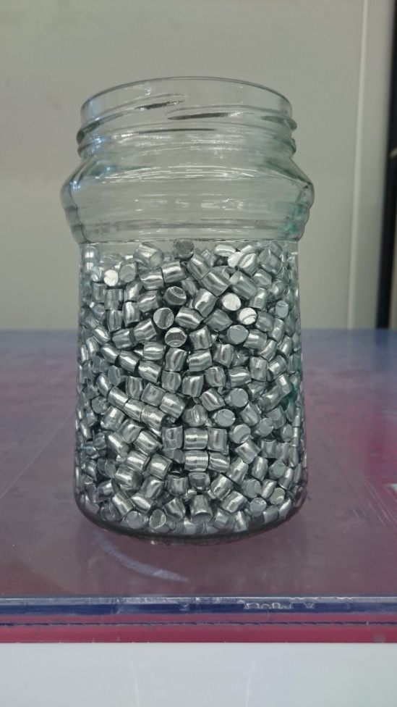

* + - 1. 烤箱烤30分鐘後即可

Bake in oven for 30min.   
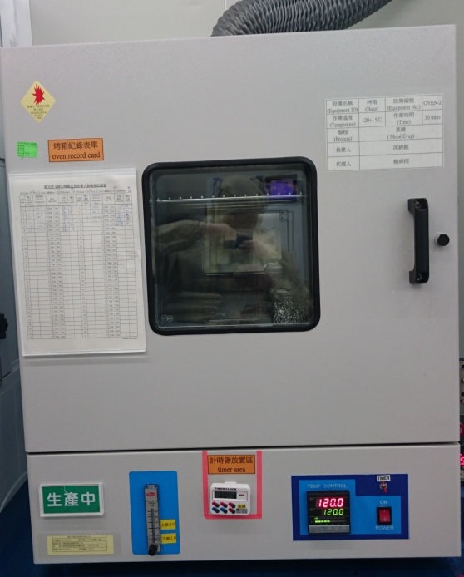

* + 1. Au金屬清洗手法 Au cleaning methode：

ACE ( 5±1 min) → IPA ( 5±1 min) → 硬烤Oven 155℃ ( 30±5 min)於鋁蝕刻烤箱

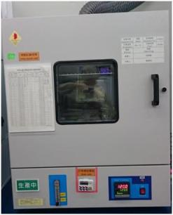

* + 1. Ni、Ti錠清洗製程與藥水如下步驟所示，以銀為例其他金屬比照辦理。  
       Metal source clean following step.

清洗會使用的容器，以DI水沖洗3次。

Before washing metal source, the fixture clean 3times by DI Water.

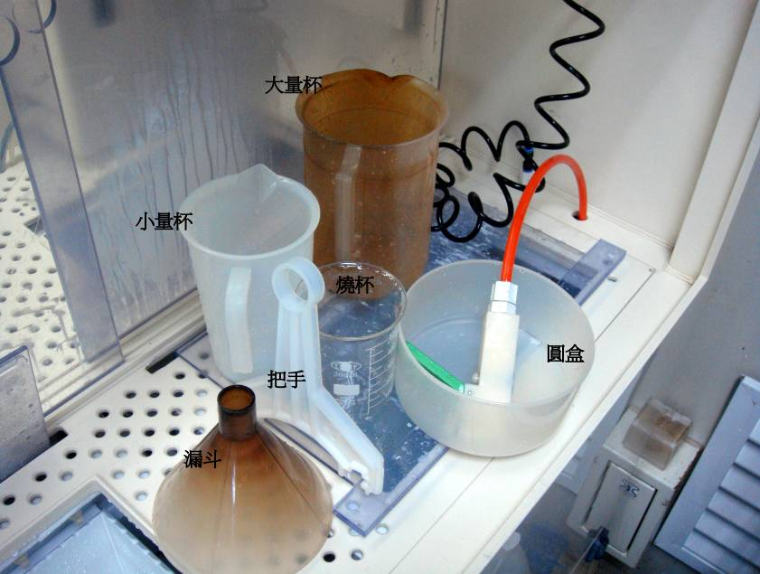

酸液配置：清洗銀的酸液，其比例如下：

Potions ratio as following:  
硝酸HNO3：醋酸CH3COOH：水H2O = 7：20：8調配，  
硝酸HNO3：醋酸CH3COOH：水H2O = 140：400：160(單位毫升。)

清洗步驟一：取欲清洗之銀錠，放置圓盒中。

Step1: Metal source into the clean fixture.

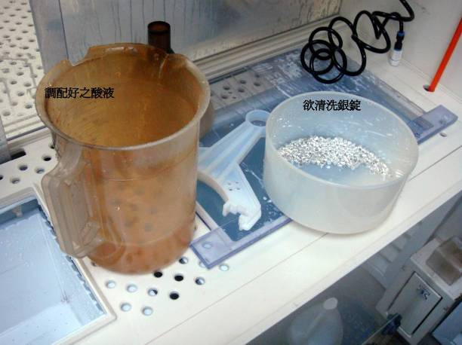

清洗步驟二：

將大量杯中調配好酸液緩緩倒入圓盒中，並開始使用把手慢慢攪拌使反應均勻，攪拌過程約30±2sec。

Setp2:

Potions into the clean fixture, then wash metal source by handle shaking

30±2sec

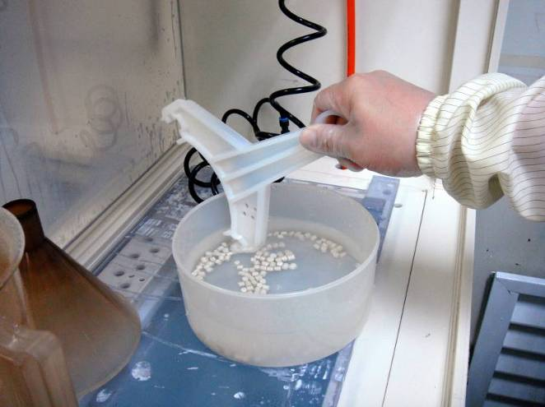

清洗步驟三：

攪拌後，銀錠在圓盒內靜置10±0.1min，然後將圓盒中酸液與金屬緩緩倒入大量杯，用大量杯將酸液倒在QDR槽(QDR設定排放)，並邊倒酸邊沖水，此動作維持10分鐘

Step3:

After washing, metal source standby 10±0.1min, then warp potions into the

QDR tanks, at the same time, DI water wash10min.

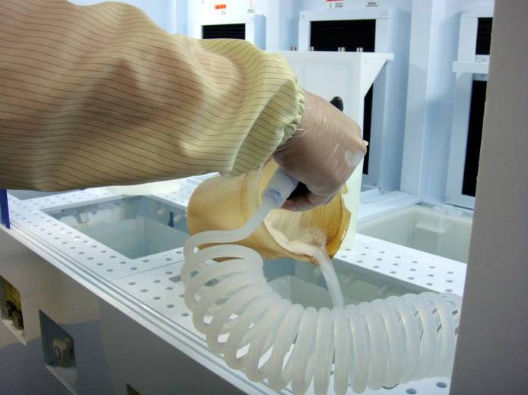

清洗步驟四：

重複步驟一、步驟二、步驟三的動作為一清洗循環，要做三個循環。

Step: Repeat step1 to step3 3 times.

清洗步驟五：

將水倒掉，將銀錠倒入圓盒中，再倒入IPA攪拌10±2sec清洗一下，將IPA倒掉完成清洗。

Step5:

To swap DI water, metal source into the clan fixture, then use IPA clean

10±2sec, finally swap it.

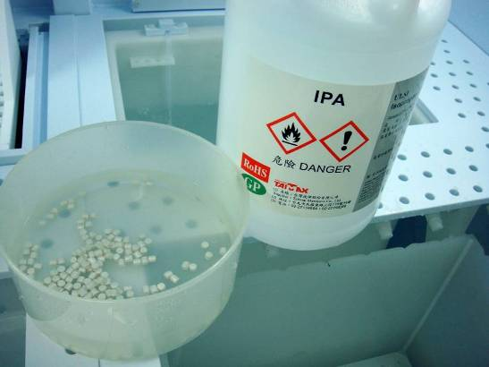

IPA清洗

清洗步驟六：

將IPA清洗完成的銀錠倒在擦拭紙上，去除多餘的液體，再放置燒杯中。

Step6:

After IPA washing, metal source put on the clean clothes, waiting for dry, then

Put in the beaker.

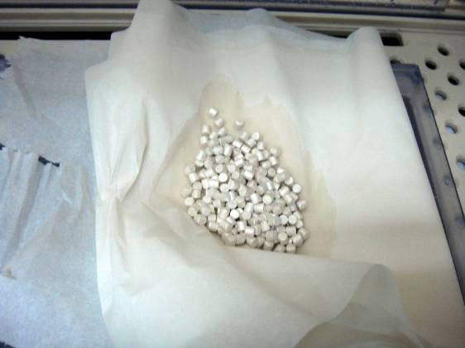

擦拭紙去除多於IPA

清洗步驟七：將銀錠倒入燒杯放入120±10℃烤箱中，放置20±0.5min。

Step7: hard baked at 120±10℃, 20±0.5min.

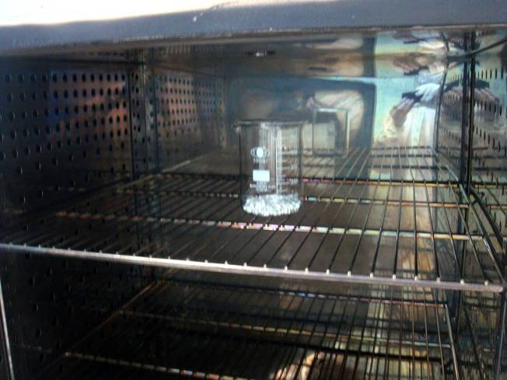

清洗步驟八：

烤完的銀錠用漏斗將銀錠從燒杯倒入專用的玻璃瓶中，烤完之銀錠需立即置入保險箱中即可。

Step8:

After baking, metal source must be placed in the glass bottles, then put in the safe cabinet

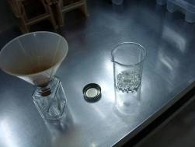

* 1. 背金藥水調配Solution mixture
     1. 調配比例 Mixture ratio

|  |  |  |
| --- | --- | --- |
| 產品  Products | 調配比例  Mixture ratio | 調配容量  Mixture capacity |
| 4~6吋(inch) wafer | H2O : HF  (10:1) | 1000cc:100cc |
| 4~6吋(inch) wafer | H2O : HF  (50:1) | 10000cc:200cc |
| 4~6吋(inch) wafer | H2O : HF  (100:1) | 7000cc:70cc |

備註：藥水調配容量僅供參考，依槽體容量大小調整。

Remark：Mixture capacity for reference will change according to bench.

* + 1. HF溶液換新時或交接前，將當班作業片數，及總累積片數記錄於溶液更換紀錄表(FMP020009)，倘若該班無作業則不須紀錄  
       When replacing HF or before handover, record the number of tablets worked on the shift and the total cumulative number of tablets in the solution replacement record sheet (FMP020009). If there is no operation in the shift, there is no need to record it.
    2. 背金清洗使用之無塵布、海棉棒每班更換一次。  
       Clean room paper and sponge bar will be renewed every shift.
    3. HF 100:1及50:1每班更換藥水。  
       HF 100:1及50:1 will be renewed every shift
    4. HF 10:1則為清洗累積片數達650±36片時更換藥水，若清洗未達累積片數，則2天更換一次。  
       If HF 10:1 of cleaning pellets reaches 650±36pcs, the will be replaced. If the number of pellets has not been reached, then will be replaced every 2 days.
    5. 請每班作業人員於交接前於表單中紀錄當班作業片數，及總累積片數，倘若該班無作業則不須紀錄  
       Please record the number of pcs and the cumulative number of pcs in the table before the handover, If there is no working in that shift, no need to record it in the table.
    6. 更換新的海綿及無塵濾紙時，請將海綿浸泡在藥水盤中至少12小時後再進行清洗作業。  
       When replacing the new sponge and clean room filter paper, soak the sponge in the HF tray for at 12 hours least before cleaning.
    7. 背金清洗使用海綿每班清洗，添加新藥水HF10:1時不可殘留HF於盤內，添加新藥水(約2000cc)須完全沾濕海綿。  
       Sponge will be cleaned every shift and change new HF10:1 before pour away solution. Sponge should be wetted completely with new HF10:1 solution (~2000cc).
    8. 背金清洗用海綿墊應每個月1日更換(若遇假(節)日，則順延一日)，並記錄表單(FMP02009-15)  
       Sponge pad for backside metal wash should be replaced every 1st of month (If happen day off or holiday, please delay one day), and record the Table (FMP02009-15).
  1. 背金蒸鍍前清洗 wafer wash before backside metal evaporation：
     1. HF浸泡清洗：整批浸泡HF 100：1或HF 50:1溶液持續搖晃，再以QDR沖水。  
        HF clean：Dip wafers in HF 100：1 or HF50:1 solution with shaking, and then QDR wash it.
     2. 背面HF刷洗：  
        先將欲作業片數分片放置於沾濕HF10:1的海棉上，晶背須能完全碰觸海綿，而晶片背面未脫水區域再用沾濕海綿棒刷洗，並清洗至晶背能快速脫水，才可移至QDR內清洗，而QDR持續下給水到全部清洗完成。  
        First, the wafers to be worked on a sponge moistened with HF10:1. The wafer backside can completely touch the sponge. The undehydrated area on the backside is then scrubbed with the wet sponge stick and cleaned until the backside can be dehydration, then can be moved to the QDR for cleaning, and able to continuous supply water until cleaning is completed.  
        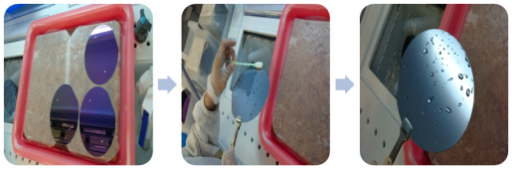  
          
          
        若脫水如有延著研磨痕殘水下判定為脫水NG，應開立異常請工程確認

If there is residual water along the grinding marks, it is judged as dehydration NG, and an abnormality should be opened. Please confirm with the engineer.  
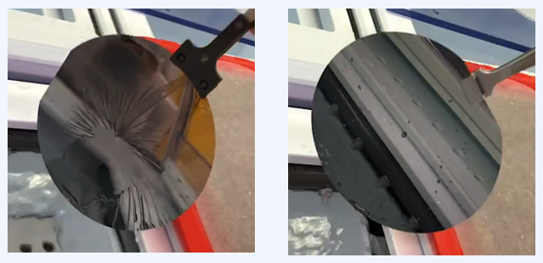  
 NG OK

* + 1. QDR清洗QDR clean：

清洗流程需遵照下圖表Clean procedure should follow below  


* + 1. 待清洗材料不放置於蝕刻槽內，以免槽內酸氣影響外觀。  
       Wafer wait for washing can't place in the bench to avoid acid vapor effect appearance of wafer.
    2. QDR清洗完成後，晶片停滯QDR時間不可大於30分鐘。  
       After QDR wash, wafer can't place in tank over 30min.
    3. 晶片旋乾步驟Wafer Spin-Dry or oven procedure：
       1. 未經研磨之產品QDR後可用旋乾機將水分旋乾，旋乾機程式不開啟Rinse功能，取出旋乾材料須確認Cassette包覆晶片區域是否有水殘留，若有旋不乾情形立即通知領班、工程處理。  
          Products without grinding use spin-dry to dry off wafer. Spin-dry should close rinse function. After spin dry, check wafer outside if wafer residue or not. If find wafer residue on wafer, notice leader and engineer.
       2. ZDN、FZD與FDN產品依Run card說明流程作業。   
          Backside clean methods of ZDN, FZD and FDN products as following the run card description.

備註1：未備註之產品依Run card作業。  
Note1：If products are not marking in table, follow the run card.

* 1. 晶片裝置轉盤上Wafer place on the dome
     1. 將晶片正面(欲鍍面)朝上置於蒸鍍轉盤上，以彈簧夾緊  
        Front-side of wafer faces up to place on dome. Use spring to fix wafer.
     2. 因需要監測蒸鍍機台的蒸鍍Al時鍍鍋內外圈的膜厚均勻度，因此蒸鍍Al時不論膜厚，除內側的載玻片外，需額外在鍍鍋外圈黏貼一片預先裁切好大小的載玻片(如附圖所示)，並將內、外圈的膜厚量測數據紀錄於蒸鍍區使用記錄表及SPC表格中。  
        When evaporating Al, in addition to the monitoring glass slide inter ring, an additional piece of glass slide is attached to the outer ring of the plating pot, and record the film thickness of center and outer rings, on the table and SPC sheet.

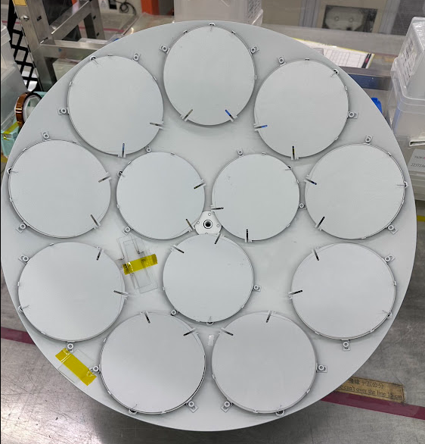

* 1. 背金蒸鍍檔片清洗方式Back Au evaporated film Dummy clean method
     1. 清洗流程 Clean procedure of dummy

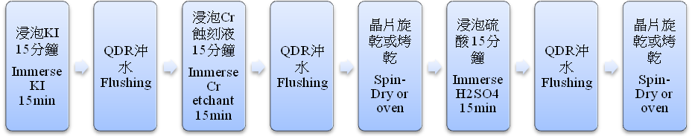

※H2SO4請使用B-7專用槽

※H2SO4 is limited in metal etching bench used.

* 1. 晶片裝置轉盤上 Wafer place on the dome
     1. 3FWF蒸鍍站Dummy片僅供薄片背鍍Au製程使用，請產線作業前將檔片依KI-15mins→Cr-15mins→H2SO4-15mins進行清洗，並將其記錄在蒸鍍擋片清洗記錄表(FMP020077)

The Dummy wafer of the 3FWF evaporation station is only used for the thin wafer to Au back evaporation. Please clean the sheet according to KI-15mins→Cr-15mins→H2SO4-15mins before production line operation, and record it on the sheet (FMP020077)

* + 1. 擋片晶面(晶邊外圈2排和產品破片專用之擋片除外)不可殘留金屬，有殘留金屬時，需再清洗，當擋片不堪使用時，需淘汰報廢。  
       Metal can’t remain on wafer surface (except outer 2 lines of wafer and broken wafer use only). If find the metal residual, clean wafer again. When dummy is unusable, reject it.
    2. 重新挑選未鍍過金屬之擋片，去除晶面之所有膜質，並需重新鍍新 Nitride 膜(1300 ± 50A)即可當檔片使用。  
       Choose dummy without metal, remove oxidation, coat new SiNx film and then that can be a dummy for evaporation.
    3. 鍍背金前清洗完的晶片放置於晶片傳遞盒，須確認晶片表面不可有水，才可將材料放置於蒸鍍機內，晶片傳遞盒每周需清洗一次。  
       Use transfer box to transfer wafer after pre-clean. Evaporation machine is not allowed wafer remain water residual.
    4. 晶片清洗、烘烤完後，不得在蒸鍍機外停留超過2小時，否則須重新清洗、烘烤作業。  
       If wafer stay out of evaporation exceed 2 hour after cleaning, need to clean again.
    5. 若發生晶片背面脫金之異常，請立即通知工程確認，經工程確認後須執行背金重工之產品，作業人員請參照工程開立重工單流程，進行背金重工作業。  
       If find the peeling of backside metal, notice engineer. When engineers determine wafer need to rework, operator should follow RM process to rework wafer.
    6. OSRAM產品(、98、118A)每Run需量測背金厚度，其他產品每週三量測一次(Run)背金蒸鍍Cr / Au後載玻片上之Cr / Au總厚度。  
       Osram products measure the backside metal thickness of glass every run. Another products with Cr/Au evaporation measure thickness every Wednesday.
    7. 同鍋蒸鍍產品，不可清洗後再分批作業，並須在限定時間內完成蒸鍍作業  
       The product in the same evaporation run can’t be divided after clean process, and it should be finish the evaporation operation within a limited time.
    8. 帶有光阻材料進蒸鍍機，不可與正常品一起作業，作業完成後需安排空鍍後才可作業正常產品  
       Wafer with PR (Lift off process) could not run with normal wafer. After evaporation with PR wafer, machine need to empty evaporation once.
  1. 蒸鍍機操作程序Evaporator operation process：
     1. E-gun蒸鍍機一 E-gun 1：
        1. 冷凍幫浦須完成待機狀態，並將功能選擇單元之各按鈕復歸。

When cryo pump is ready, all of components revert.

* + - 1. 將基材加熱控制單元之自動/手動開關置於自動並設定溫度控制器之基材加熱溫度

Heating controller keep auto mode and set temperature.

* + - 1. 將夾具旋轉控制單元之自動/手動開關置於自動並設定選轉控制器之旋鈕以控制基材旋轉之速度

JIG Rotation control keep auto mode and set speed rate.

* + - 1. 將熔床選擇單元之手控/自動開關置於自動之位置

Boat select keep auto mode.

* + - 1. 將電子槍控制面板上之鑰匙置於自動位置，高真空控制開關置於自動，電子束控制開關置於程式控制，X-軸、Y-軸控制開關置於手動，HVCONTROL為MANUAL，METER READ為HV DC，METER READ為1A EMISSION，EMISSION CONTROL為PROGRAM  
         Set Key at “auto” in the panel of e-gun controller. High vacuum switch set the “auto”. E-beam controller switch set “program” control. X-axis and Y-axis switch set manual. HV control set manual, Meter read set HV DC, Meter read set 1A emission, and emission control set program.
      2. 設定Auto Deposition Unit面板上之各項條件：  
         Set components parameters at panel of auto deposition unit
         1. HEAT KEEP ON/ STEP HEAT開關為 HEAT KEEP ON  
            HEAT KEEP ON/ STEP HEAT set HEAT KEEP ON

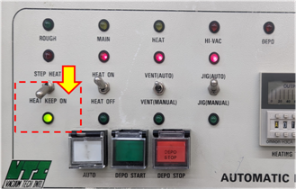

* + - * 1. HEAT ON/ HEAT OFF開關為HEAT ON  
           HEAT ON/ HEAT OFF set HEAT ON
        2. JIG AUTO / JIG MANUL開關為JIG AUTO  
           JIG AUTO / JIG MANUL set JIG AUTO
        3. VENT AUTO / VENT MANUAL開關為VENT AUTO  
           VENT AUTO / VENT MANUAL set VENT AUTO
        4. HEAT TIMER之時間為15+10分鐘  
           HEAT TIMER set 15+10min
        5. COOLING TIMER之時間為15+10分鐘  
           COOLING TIMER set 15+10min
      1. 上述各項完成後，按下自動鍍膜單元面板上之自動及鍍膜開始按鈕，即可完成蒸鍍之功能，其動作可由自動鍍膜單元面板第一排LED 指示出  
         After finish above, press “start” in the panel of auto control components. The auto evaporation situation will show by LED lens.
      2. 確認Thickness Control CRTM控制器自動鍍膜之程式。  
         Check CRTM controller program.
      3. 上述各項完成後，按下自動鍍膜單元面板上之自動及鍍膜開始按鈕，即可完成蒸鍍之功能，其動作可由自動鍍膜單元面板第一排LED 指示出.  
         After finish above, press “start” in the panel of auto control components.  
         The auto evaporation situation will show by LED lens.
      4. 完成鍍膜之後，等待一段鍍源冷卻之時間(約15分鐘)。  
         After evaporation, wait 15min for source cooling.
      5. 完成鍍源冷卻之後，再等一段真空腔之冷卻時間(冷卻計時器設定10分鐘)。  
         After source cooling, wait the times for chamber cooling (cooling time set 10min).
      6. 真空腔冷卻後，進行真空腔破真空之動作。  
         After chamber cooling start vent function.
      7. 當真空腔破真空至大氣時，即完成整個自動鍍膜之流程，結束指示燈亮，按下自動停止以停止製程，並復歸自動及鍍膜開始鈕。  
         When vent to atmosphere, auto evaporation process is finished and end lens will light. Press close to stop the process and revert auto evaporation “start” key.
      8. 鍍膜途中若須停止進行，則可按下鍍膜停止鈕，以中止進行。  
         If want to shut down machine, press “stop” to cancel process.
    1. E-gun蒸鍍機二、三 E-gun 2、3：
       1. 停止抽真空 Stop [evacuation](http://terms.naer.edu.tw/detail/120558/)：按下[抽真空]鍵，此時會出現一浮動視窗，選擇並按下[停止]鍵   
          Press “[evacuation](http://terms.naer.edu.tw/detail/120558/)” button and show the window choose “stop” button.

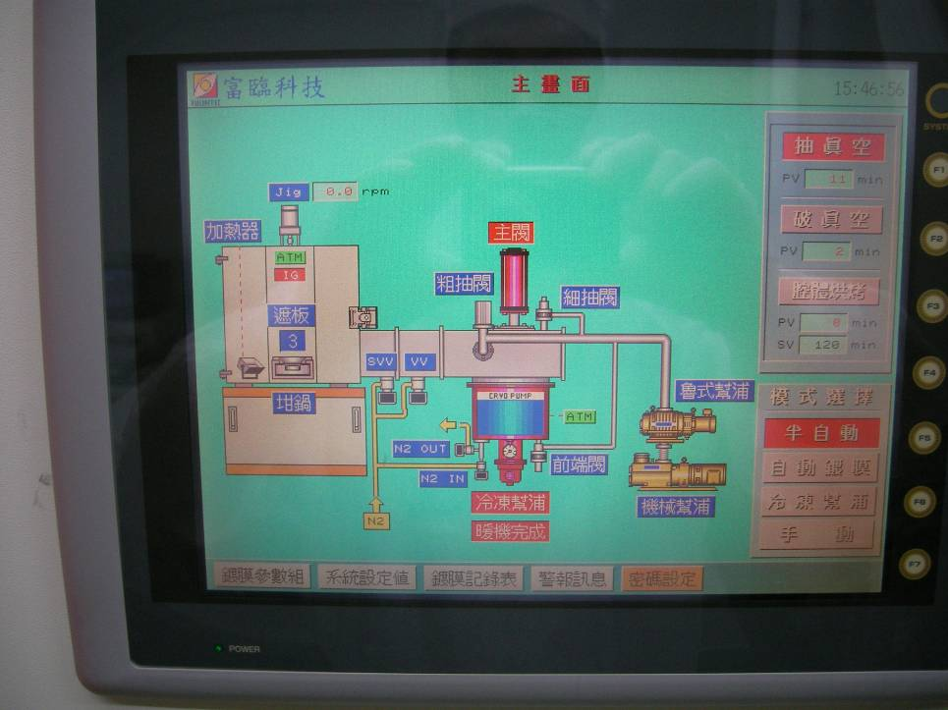

* + - 1. 破真空 Vent：按下[破真空]鍵，此時出現一浮動視視窗，選擇並按下[停止]鍵   
         Press “Vent” button and show the window choose “stop” button.
      2. 停止半自動 Stop semiautomatic mode：按下[半自動]，此時出現一浮動視窗，選擇並按下[關閉]鍵

Press “semiautomatic mode” button and show the window choose “close” button.

* + - 1. 按下門邊紅鍵，打開腔體

Press button to open the chamber.

* + - 1. 將材料置入腔體內並試轉一下DOME有無卡住

Load wafer and test dome rotary.

* + - 1. 將門關上，並按下門邊紅鍵以真空吸住腔門

Close door and press button to close the chamber.

* + - 1. 按下[自動鍍膜]，此時出現一浮動視窗，選擇並按下[開始]鍵作業

Press “auto mode” button and show the window choose “start” button.

* + - 1. 當機台響鈴後，按下[開始鍍膜]。  
         When jump to evaporation process machine will alarm, press “start” to start the process.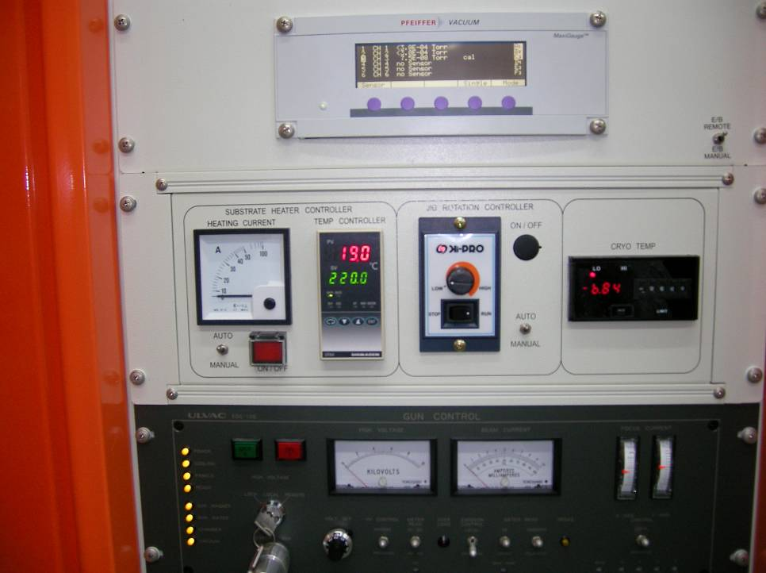
      2. 蒸鍍結束待溫度下降後，取出晶片  
         Wait for wafer cooling and load out wafer.
      3. 恢復抽真空 Keep at low pressure
         1. 按下[半自動]，此時出現一浮動視窗，選擇並按下[開始]鍵  
            Press “semiautomatic mode” button and show the window choose   
            “start” button.
         2. 按下[抽真空]，此時出現一浮動視窗，選擇並按下[開始]鍵  
            Press “[evacuation](http://terms.naer.edu.tw/detail/120558/)” button and show the window choose “start”  
            button.
    1. E-gun蒸鍍機四 E-gun 4：
       1. 按”登錄”鍵(step1)並輸入帳號與密碼(step2)，密碼輸入完成後按下”確認”鍵 (step3)  
          Push ”Login” button , and key in the account number and password, then push “confirm” button.  
          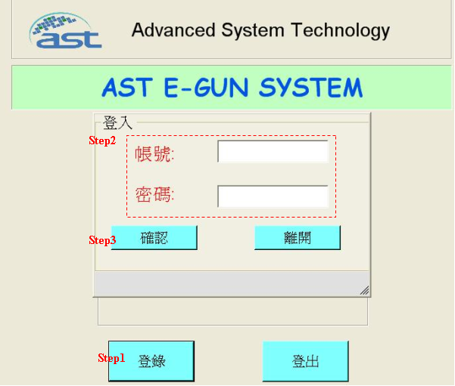
       2. 選擇程式(step4)後,按下”寫入”鍵(step5)，檢查鍍膜參數(step6)，按下”開始”鍵(step7)   
          Select program(step4), push “Load” button, check evaporation coating parameters, then push “start” button.  
          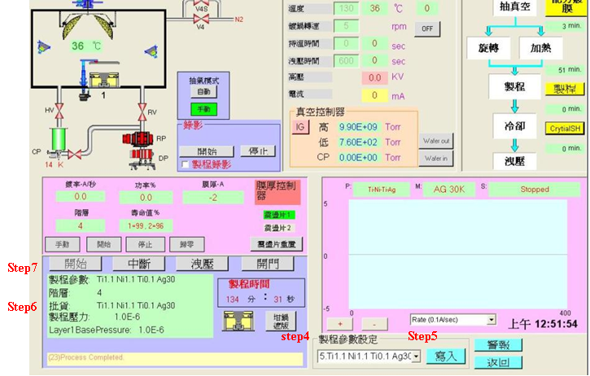
  1. 自動鍍膜之程式清單Metal evaporation program list：
     1. E-gun蒸鍍機台程式對照表 Evaporation recipe for E-gun machine.

|  |  |  |  |  |  |  |
| --- | --- | --- | --- | --- | --- | --- |
| 蒸鍍種類  Metal Type | 蒸鍍程式  Evaporation Program | | | | 厚度  Thickness | 金屬用量Number of metal  (克重/鍋) |
| 鋁一 Al Machine#1 | 鋁二 Al Machine#2 | 鋁三 Al Machine#3 | 鋁四 Al Machine#4 |
| Al-35K | #35 | #35 | #35 | #7 | 35 ± 5KÅ | 12.6 ± 0.2 g |
| AlSi-35K | #36 | #36 | #36 |  | 35 ± 5KÅ | 12.6 ± 0.2 g |
| AlSi-25K | #37 | #37 | #37 |  | 25 ± 5KÅ | 9.2 ± 0.2 g |
| Al-15K | #31 | #31 | #31 | #9 | 12.5 ± 2.5KÅ | 5.4 ± 0.2 g |
| Al- 25K | #30 | #30 | #30 | #8 | 25 ± 5KÅ | 9.2 ±0.2 g |
|
| Al-28K | #28 |  | #28 |  | 28 ± 5KÅ | 9.6 ±0.2 g. |
| Al-30K | #61 | #61 |  | #49 | 30± 5KÅ | 10.8 ±0.2g |
| Ti-2K/Al-35K |  |  | #13 #35 | #16 | 35± 3KÅ | Ti:8 ±0.4g  Al:12.6 ± 0.2 g |
| Al-2K | #50 | #50 | #50 | #32 | >2KÅ | Al:0.7 ±0.2g |
| Ti-2.5K/Ni-3K/Ag-3K |  |  | #21 #22 #23 |  | 8.5± 2KÅ | Ti:8 ±0.4g  Ni:7.2 ±0.2g  Ag:6.6 ±0.5g |
| Ti-1K/Ni-0.7K/Ag-1K |  |  | #14 #38 #39 |  | 2.7± 2KÅ | Ti:2.6 ±0.4g  Ni:1.7 ±0.2g  Ag:2.2 ±0.5g |
| Ti-1K/Ni-3K/Ag-10K |  |  |  | #40 | 14± 2KÅ | Ti:2.6 ±0.4g  Ni:7.2 ±0.2g  Ag:22 ±0.5g |
| TiNiAg-10K/Sn-40K |  |  |  | #37 | 56± 5KÅ | TiNiAg:10 ±0.2g  Sn:35 ±0.4g |
| Al-10K/Ni-5K/Au-2K |  |  | #1 #2 #4 |  | 17± 2KÅ | Al:3.6 ±0.2g  Ni:12 ±0.2g  Au:5.1 ±0.1g |
| Au-2K |  |  | #4 |  | >2KÅ | Au:5.1 ± 0.1 g |
| Cr-200A/Au-600A |  |  | #3 #5 |  | >0.8KÅ | Cr:0.17 ± 0.2 g Au:1.5 ± 0.2g |
| Cr 1K/Ni-1.75K/ Au-1.5K |  |  | #47#42#49 |  | 4.3± 2KÅ | Cr:0.85±0.2 g Ni:4.8±0.2 g Au:4±0.2 g |
| Ti-2K/Au-2K |  |  | #13 #4 |  | 4 ± 0.4KÅ | Ti:8 ± 0.4 g Au:5.1 ± 0.1 g |
| Ni-2K |  |  | #43 |  | >2KÅ | Ni:4.8 ± 0.2g |
| Ni-5K/Au-2K |  |  | #2#4 |  | 7 ± 2KÅ | Ni:12 ±0.2g  Au:5.1 ±0.1g |

註:除Au外，每Run加金屬時注意，金屬蒸鍍源表面不可超出坩鍋高度並將金屬錠鋪平；若蒸鍍源表面不滿八分請補足金屬錠。

Except for Au,Any other metal slug could not be filled up over than crucible and level that as shown below. If metal slug is not enough, fill it up to 80%.

* + 1. E-gun 2 蒸鍍機程式表 E-gun 2 Evaporation recipe

|  |  |
| --- | --- |
| 程式碼  Recipe No. | 程式名稱  Name |
| #30 | (Al-25K) |
| #31 | (Al-15K) |
| #32 | (Al-11K) |
| #35 | (Al-35K) |
| #36 | (AlSi-35K) |
| #37 | (AlSi-25K) |
| #50 | (Al-2K) |
| #61 | (Al-30K) |

* + 1. E-gun 3 蒸鍍機程式表 E-gun 3 Evaporation recipe

|  |  |  |  |
| --- | --- | --- | --- |
| 程式碼  Recipe No. | 程式名稱  Name | 程式碼  Recipe No. | 程式名稱  Name |
| #1 | Al-10K | #31 | Al-15K |
| #2 | Ni-5K | #35 | Al-35K |
| #3 | Cr-0.2K | #36 | AlSi-35K |
| #4 | Au-2K | #37 | Ti-1K |
| #5 | Au-0.6K | #38 | Ni-0.7K |
| #10 | Au-10K | #39 | Ag-1K |
| #11 | Au-0.8K | #40 | AlSi-25K |
| #12 | Ti-0.5K | #42 | Ni-1.75K |
| #13 | Ti-2K | #43 | Ni-2K |
| #15 | Au-1K | #47 | Cr-1K |
| #21 | Ti-2.5K | #49 | Au-1K |
| #22 | Ni-3K | #50 | Al-2K |
| #23 | Ag-3K | #57 | Ni-6K |
| #30 | Al-25K |  |  |

* + 1. E-gun 4 聚昌蒸鍍機程式表 Evaporation recipe for AST E-Gun system

|  |  |  |  |  |  |  |  |  |
| --- | --- | --- | --- | --- | --- | --- | --- | --- |
| 程式號碼  Recipe NO. | 程式名稱  Name | 設定溫度  T(℃) | 程式號碼  Recipe NO. | 程式名稱  Name | 設定溫度  T(℃) | 程式號碼  Recipe NO. | 程式名稱  Name | 設定溫度  T(℃) |
| 0 | AL |  | 20 | TI 3K | 70 | 40 | Ti1kNi3kAg10k | 70 |
| 1 | TI | 70 | 21 | TI NI AG FS | 70 | 41 | AL 10K | 75 |
| 2 | NI | 70 | 22 | AL 20K | 70 | 42 | Ag10KSn40K | 70 |
| 3 | AG | 70 | 23 | TEST-23.5 |  | 43 |  |  |
| 4 | TEST |  | 24 | NI3KAG10K | 70 | 44 |  |  |
| 5 | Ti1.1 Ni1.1 Ti0.1 Ag30 | 130 | 25 | TI1.5KNI2KAG15K BS | 130 | 45 |  |  |
| 6 | Ti1.1 Al50 | 150 | 26 | Ti1kNi3kAg20k FS | 70 | 46 |  |  |
| 7 | Al 35K | 75 | 27 | Ti1kNi3kAg20k BS | 130 | 47 |  |  |
| 8 | Al-25K | 75 | 28 | TINIAG2K2K20K FS | 70 | 48 |  |  |
| 9 | Al 13K | 75 | 29 | TI1KNI0.7KAG1K BS | 130 | 49 | AL 30K | 75 |
| 10 | Ni1.1 Ti0.1 Ag30 | 130 | 30 | TI1KNI1KAG1K TEST | 70 | 50 |  |  |
| 11 | Ni Ti Ag FS | 70 | 31 | NI3K Ag20K | 70 | 51 |  |  |
| 12 | XXXX |  | 32 | AL 2K | 75 | 52 |  |  |
| 13 | AL 35K | 75 | 33 | Ti3KAg10KSn40K | 70 | 53 |  |  |
| 14 | Al-19.5K | 150 | 34 | Sn 40K | 70 | 54 |  |  |
| 15 | Al-4.5K | 150 | 35 | Ti3KAg10KSn20K | 70 | 55 |  |  |
| 16 | Ti-Al 2K-35KA | 75 | 36 | Sn 20K | 70 | 56 |  |  |
| 17 | TI 2K | 70 | 37 | TiNiAg10KSn40K | 70 | 57 |  |  |
| 18 | NI 3K | 70 | 38 | TiNiAg10KSn20K | 70 | 58 |  |  |
| 19 | TI2K NI3K AG30K | 130 | 39 | TI1.1NI1.1TI0.08AG30 | 70 | 59 |  |  |

* + 1. (Al#2、Al#3)E-gun坩鍋位置配置 Crucible place

|  |  |  |  |  |
| --- | --- | --- | --- | --- |
| 蒸鍍種類 Metal Type | 坩鍋1 Crucible 1 | 坩鍋2 Crucible 2 | 坩鍋3 Crucible 3 | 坩鍋4 Crucible 4 |
| Al |  |  |  | Al |
| Ti / Al | Ti |  |  | Al |
| Ti / Ni / Ag | Ti | Ni | Ag |  |
| Al / Ni /Au |  | Ni | Au | Al |
| Au |  |  | Au |  |
| Cr / Au |  | Cr | Au |  |
| Cr/Ni/Au | Cr | Ni | Au |  |
| Ti/Al/Ni/Au | Ti | Ni | Au | Al |
| Ti / Au | Ti |  |  |  |
| AlSi |  |  |  | AlSi |

備註1:鋁1僅作業鋁及鋁矽，固定於坩鍋3作業

Note 1:Al#1, only used crucible 3 evaporated Al and AlSi

備註2：未備註之產品依Run card作業。

Note2：If products are not marking in table, follow the runcard.

備註3：若使用不在表單內程式，需知會當站工程師。

Note3：If run the program do not remark in table, should notice evaporating engineer.

備註4：若程式未定義厚度規格，依Run card條件作業

Note4：If products are not defined metal thickness, follow the runcard remarking.

* + 1. 機台參數設定Evaporation parameter：

|  |  |  |  |  |
| --- | --- | --- | --- | --- |
| 機台  Machine | 鋁一 Al Machine#1 | 鋁二 Al Machine#2 | 鋁三 Al Machine#3 | 鋁四 Al Machine#4 |
| 腔體加熱溫度  Heating temperature | 75±5℃ | 75±5℃ | 75±5℃ | 程式控制 Recipe control |
| 轉速  JIG speed | 10~15 rpm | 9~13 rpm | 9~13 rpm | 9~13 rpm |

* + - 1. 若產品作業溫度與上表不同，作業溫度需註記在Runcard，並通知領班及設備進行調整

If heating temperature will be tuned for products, should remark temperature in Runcard and notice leader and equipment to modify.

* + 1. 程式參數設定Evaporation recipe：

Program 030 /025

|  |  |  |  |
| --- | --- | --- | --- |
|  | PHASE | PARAM | FINISH |
| # | FUNCTION | VALUE | EVENT |
| 1 | READY |  | PORTO2LH |
| 2 | PWR RAMP01 | 25% | 00:30 |
| 3 | PWR CAST01 | 25% | 00:30 |
| 4 | PWR RAMP02 | 30% | 00:30 |
| 5 | PWR CAST02 | 30% | 00:30 |
| 6 | RATE RAMP01 | 8.00 A/S | 00:20 |
| 7 | RATE CNST01 | 8.00 A/S | 10.00KA |
| 8 | RATE RAMP02 | 10.00 A/S | 00:10 |
| 9 | RATE CNST02 | 10.00 A/S | 23.50KA |
| 10 | PWR RAMP03 | 20% | 00:10 |
| 11 | PWR CNST03 | 20% | 00:05 |
| 12 | PWR RAMP04 | 0.00% | 00:10 |
| 13 | PWR CNST04 | 0.00% | --- |

Program 031

|  |  |  |  |
| --- | --- | --- | --- |
|  | PHASE | PARAM | FINISH |
| # | FUNCTION | VALUE | EVENT |
| 1 | READY |  | PORTO2LH |
| 2 | PWR RAMP01 | 25% | 00:40 |
| 3 | PWR CAST01 | 25% | 00:40 |
| 4 | PWR RAMP02 | 30% | 00:30 |
| 5 | PWR CAST02 | 30% | 00:30 |
| 6 | RATE CNST01 | 11.00 A/S | 13.50KA |
| 7 | PWR RAMP03 | 20% | 00:10 |
| 8 | PWR CNST03 | 20% | 00:05 |
| 9 | PWR RAMP04 | 0.00% | 00:10 |
| 10 | PWR CNST04 | 0.00% | --- |

Program 035

|  |  |  |  |
| --- | --- | --- | --- |
|  | PHASE | PARAM | FINISH |
| # | FUNCTION | VALUE | EVENT |
| 1 | READY |  | PORTO2LH |
| 2 | PWR RAMP01 | 25% | 00:30 |
| 3 | PWR CAST01 | 25% | 00:30 |
| 4 | PWR RAMP02 | 30% | 00:30 |
| 5 | PWR CAST02 | 30% | 00:30 |
| 6 | RATE RAMP01 | 8.00 A/S | 00:20 |
| 7 | RATE CNST01 | 8.00 A/S | 10.00KA |
| 8 | RATE RAMP02 | 10.00 A/S | 00:10 |
| 9 | RATE CNST02 | 10.00 A/S | 34.50KA |
| 10 | PWR RAMP03 | 20% | 00:10 |
| 11 | PWR CNST03 | 20% | 00:05 |
| 12 | PWR RAMP04 | 0.00% | 00:10 |
| 13 | PWR CNST04 | 0.00% | --- |

DENSITY: 2.7

Z- RATIO: 1.08

TOOLING: 70.00% GAIN: 10.0

TIME-C:1.00

LIMIT:10.0

MAX POWER:85%

MAX POWER STOP:00:05MS

SENSOR SHUTTER OPEN : 00.00MS

SENSOR SHUTTER CLOSE:00:00MS FULL SCALE THK:1.000KA

FULL SCALE RATE:1.000A/s

FILTER TC:10.0

SENSOR NO:1

SENSOR NO:1

XTAL CHANGE

FREQ:4.200MHZ

HEARTH NO.:001

備註：蒸鍍機台參數僅供參考，工程依作業情況調整。

Remark：Evaporation parameters are just for reference. That will be changed by engineer.

* + 1. 每鍋金屬使用量需記錄於矽元件蒸鍍區使用記錄表(FM0901155)

Amount of evaporation metal should record in FM0901155.

* + 1. 金屬用量做參考使用，添加金屬後坩鍋金屬量仍需高於8分滿，但不得全滿，若作業後金屬高度低於6分滿，請通知領班及工程確認

Amount of evaporation metal is for reference only. Metal should be filled up above 80% but not all fulling, in crucible before evaporating. If amount of metal is less than 60% after evaporating, notice leader and engineer to check.

* 1. 蒸鍍作業注意事項Notes of evaporation operation：
     1. 鋁蒸鍍時，靶材部分Al#1~Al#3為使用Al cone(料號: RBC0-1032)，Al#4為使用slug預融而成。第一RUN時仍需要進行預融動作，以減少爆鋁的情形發生。

Whan Al evaporation, the Al target parts Al#1~Al#3 are use of Al cone, and Al#4 is using slug to pre-melted . It still needs to be performed during the first RUN. Pre-melting action to reduce the occurrence of Al explosion.

* + 1. 除Au外，每Run加金屬時注意，金屬蒸鍍源表面不可超出坩鍋高度並將金屬錠鋪平(如下圖)；若蒸鍍源表面不滿八分請補足金屬錠

Except for Au,metal slug could not be filled up over than crucible and level that as shown below. If metal slug is not enough, fill it up to 80%.

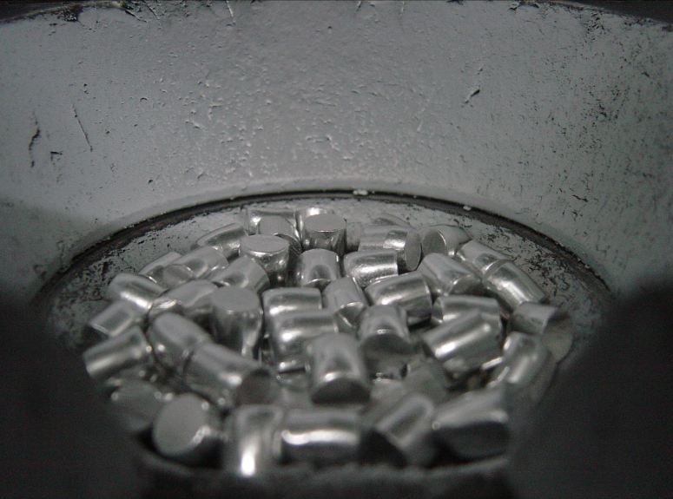

NG情況：Al錠和AlSi錠擺放分散或過量導致坩鍋外圍殘留鋁錠

NG: Al slug places dispersion and excess makes al residue near crucible

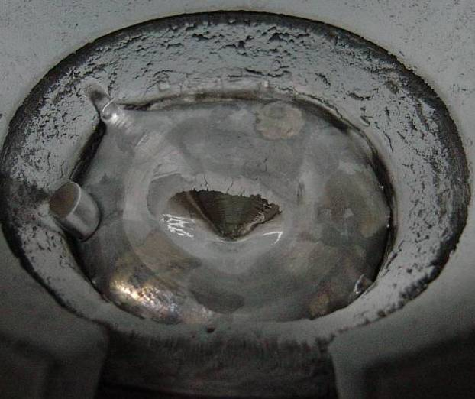

* + 1. 每鍋作業記錄鍍鋁次數於矽元件蒸鍍區使用記錄表(FM0901155)上。  
       Record evaporation times in Silicon Device evaporation record table (FM0901155).
    2. 請人員每RUN作業前檢查遮版開啟時不得遮蔽到二級板斜面上方，以免影響後續產品電性

Please check every run when the shutter opend, should not be blocked above the slope of the secondary board.

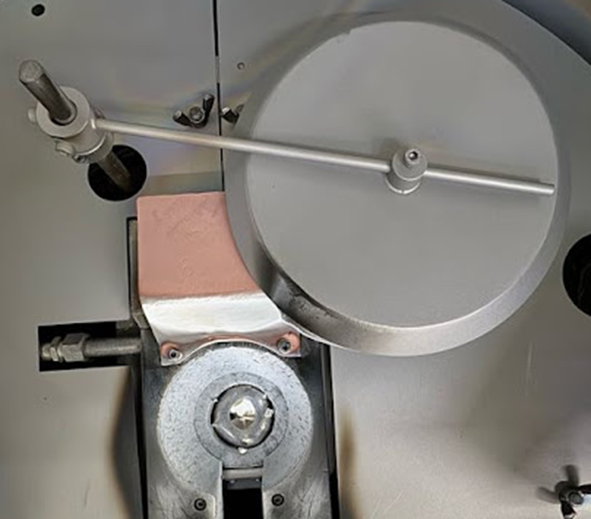

(NG)

* + 1. 空鍍或預融(有執行蒸鍍程式)亦需記錄於矽元件蒸鍍區使用記錄表(FM0901155)上

Empty evaporation or pre-melting run with evaporation program should be recorded in Silicon Device evaporation record table (FM0901155).

* + 1. 機台鍍鋁抽真空時間不可超過60分鐘(鋁一無法顯示抽真空時間，以機台蜂鳴響時做記錄，若現場未有作業人員允無記錄值)，並將抽真空時間及蒸鍍開始時間紀錄於表單(FM0901155)中，若抽氣時間過久請通知設備確認機台

Vacuum time can’t exceed 60min for Al evaporation. (Because AL1 can not show out vacuum time, agree no data record in table) and record the vacuum start time and evaporation time in the form (FM0901155). If vacuum time exceed, notice equipments to check machine.

* + 1. 每Run開始沈積時，需檢查E-Gun所打之位置是否位於鋁蒸鍍源表面之中央，若偏移則通知工程師調整

Check e-gun beam before evaporation. If find that is not at the center of source, notice engineer to modify it.

* + 1. 紀錄膜厚時，請分別量測載玻片的左上點及右下點，內外圈載玻片共4點。

When recording the film thickness, please measure the upper left point and the lower right point of the glass slide respectively, totally of 4 points on the center and outer ring slides.



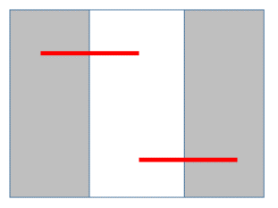

作業時請將內外圈膜厚及該批鍍鍋內圈的晶片號紀錄在RUN card上正面金屬蒸鍍後方的空白區域中，而蒸鍍區作業紀錄表上記錄內外圈膜厚共四點

Please record the center and outer ring thickness and the center ring wafer number to the blank area behind the metal evaporation on the front side of the RUN card, and the Evaporation record sheet need record the center and outer ring thickness at four points

紀錄方式如下，其中O表示外圈，C表示內圈：

The record pattern is as follows, “O” means the outer ring and “C” means the center ring:  
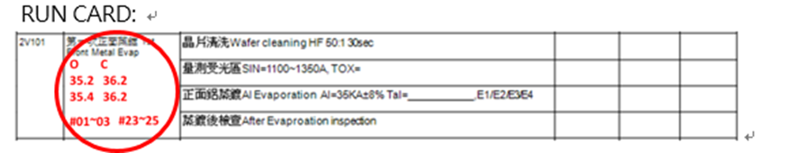  
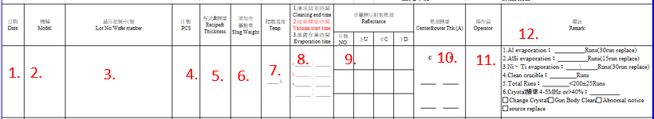蒸鍍區使用紀錄表填寫：紀錄內容分別為The recorded contents are：  
1.日期、2.機種、3.晶片批號、4.片數、5.程式&膜厚、6.添加金屬重量、7.腔體溫度、8.(1)蒸鍍前清洗結束時間、(2)抽真空開始及(3)機台作業時間、9.抽測片號及反射率、10.內外圈各2點膜厚量測、11.操作員簽名、12.(1)Al作業鍋數、(2)AlSi作業鍋數、(3)Ni、Ti作業鍋數、(4)清腔體累計鍋數、(5)總作業鍋數、(6)石英片數據、更換石英片、清腔體確認、開立異常單、更換金屬靶材。

1. Date, 2. model, 3. Wafer batch number, 4. Number of pieces, 5. Recipe & film thickness, 6. Added metal weight, 7. Chamber temperature, 8. (1) Evaporation completion cleaning End time, (2) start of evacuation and (3) machine operation time, 9. Random test of piece number and reflectivity, 10. thickness measurement at 2 points in each run, 11. Operator signature, 12. (1) Al Number of operating runs, (2) Number of AlSi operating runs, (3) Number of Ni and Ti operating runs, (4) Cumulative number of cleaning chamber, (5) Total number of operating runs, (6) Crystal information, replacement Crystal , Confirm chamber cleaning, Abnomal notice, and replace metal source.

該表單的晶片批號欄位不需填寫片號

The Wafer batch number sheet don’t need to write the wafer number  
請產線作業人員在發現膜厚超出製程規格時，將該鍋內外圈載玻片的背面寫上作業機台、日期時間、量測膜厚數據後，將載玻片放入夾鏈袋後保留，並放至於工程異常桌上，以利工程複檢。

When thickness out of process range, write the machine number, date, start time, and thickness data on the back of the glass, then placed in a zipper bag, kept and placed on the engineer abnormality table for re-inspection.

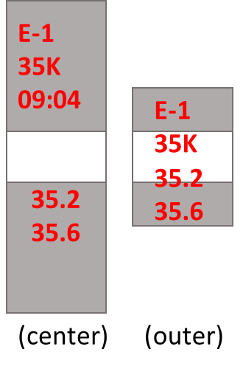

* + 1. 背金蒸鍍載玻片檢驗方式如下 Inspection method of glass for evaporation used   
       背鍍 Au：  
       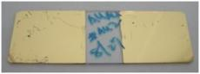 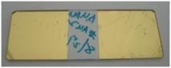  
        載玻片正面 front-side 載玻片背面 back-side

背鍍 Cr / Au：

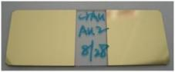 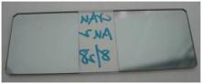

載玻片正面 front-side 載玻片背面 back-side

* + 1. SPC 管制項目及作業方式SPC Control item and operating method  
       背金SPC 管制項目Control item  
       TK0098PDN、TK118APDN、TKOX20PDN背金Cr/Au  
       背金蒸鍍厚度量測取2點／1Run並記錄於SPC  
       Backside metal thickness sample 2point /1 run to record in SPC
    2. 蒸鍍程式有做新增或修改需填寫蒸鍍區機台程式變更紀錄表(FM090143-6)

If need to create or modify the program, should record in evaporation program modify table (FM090143-6).

* + 1. 蒸鍍機有做機台設備更換(EX：電子槍模組、控制器等…)，修復後需先通知工程確認程式是否做調整，才可轉產線進行作業。

If machine need to change the equipments (EX：e-gun module、controller etc…), will notice engineer check process after repairing the machine and then be used by production.

* + 1. 帶有光阻材料進蒸鍍機，不可與正常品一起作業

Wafer with PR (Lift off process) could not run with normal wafer.

* + 1. 鍍金作業轉盤需改用背金專用轉盤

Au evaporation should use dome for backside metal evaporation only.

* + 1. 開始鍍金作業前，需確認坩鍋轉動是否正常，及火山口殘留過多金屬需先請設備工程清除，正常外觀如下圖：

Before evaporating, should check rotary motion and residue of metal nearby crucible. If residue of metal is too much, notice equipment engineer to clean it like the picture below.

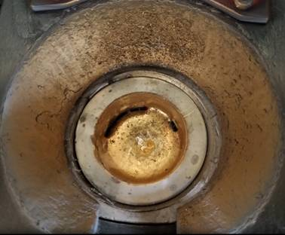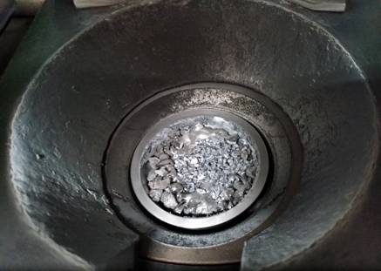

* + 1. 背鍍金材料清洗後需於2小時內進E-gun機台

The products for Au evaporation should be evaporated under 2 hours after wafer clean.

* + 1. 鍍金後不需空鍍即可切換作業其他金屬

Evaporate another type of metal after Au evaporation that could be started continually.

* 1. 產品異常檢驗項目及異常開立原則   
     Standard of Inspection Category and principle of making abnormal table

| 項次 | 異常項目  Inspection Item | 圖片  Image | | 處置  Action |
| --- | --- | --- | --- | --- |
| 1 | 缺角  Wafer with edge leakage |  | | 開立異常  write down abnormal notification |
| 2 | 晶片表面外來物污染。  例如：油墨、水痕、殘酸、  手印污染。  External contaminant  (Ex:ink,water,acid,  fingerprint..etc.) | MVC-014F | | 污染面積大於晶片5%  需開立異常  External contaminant  on wafer surface cannot more then 5% of gross die. |
| 3 | 鋁蒸鍍顏色不均  Aluminum surface with two color |  | | 通知工程並開立異常  Inform engineering and write down abnormal notification |
| 6 | 鋁反射率低  Low reflectivity of Aluminum |  | | 參照矽元件Detector鋁黑自主檢驗作業標準  (SEG-5-034)作業  Follow OI (SEG-5-034) |
| 7 | 鋁膜厚異常  Aluminum thickness out of specification |  | | 由工程判定是否重工  Determine to rework or not by engineering judgment |
| 8 | 鋁凸  Aluminum dome |  | | 使用小刀將鋁凸刮除並開立異常  Use knife to remove protruding aluminum dome and write down abnormal notification |
| 9 | 鋁墊內外圈雙色  Bicolor of Al pad | 60-2-200.jpg | | 量測內、外圈反射率  Measure inner and outer reflectivity of pad  若反射率值大於20%，為正常；低於20%已鋁黑開立異常  Both of them ≧20%, OK  One of them <20%, would write down abnormal notification follow by dark pad inspection method  外圈過小無法量測反射率即不卡此異常ex:90PD  If outer small ring area could not measure reflectivity, it is allowed (ex:90PD). |
| 10 | 掉背金(裸露Si底材)  Peeling and expose Si surface |  | | 掉背金面積大於晶片5% 需開立異常  Peeling area on wafer surface should be less than 5%. |
| 11 | 背金金凸  Au protruding | |  | 1. 金凸面積大於晶片5%需開 立異常 Au protruding wafer surface should be less than 5%. 2. AUK 產品(AUK Products) TK0080PDN、TK0330PDN背金金凸≦1%。金凸高度 ≦15um，超過需開立異常 For AUK products Au protruding wafer surface should be less than 1%  and height of protruding less than 15um. 金凸高度使用α- step 量測 Height of protruding useα- step measure. 3. 細小金凸刮除後，可續流作業 Small Au protruding after removing can pass it. |
| 12 | 背金白點  White dots on backside metal | |  | 允許  It is allowed. |
| 13 | 背金刮傷  scratches on backside metal | |  | 裸露Si底材面積大於晶片5% 需開立異常  Scratch makes backside metal expose Si surface area should be less than 5%. |
| 14 | 背金污染  Contaminant on ackside metal | |  | 污染面積大於晶片5% 需開立異常  External contaminant on wafer surface should be less than 5%. |
| 15 | 背金顏色不均  Backside metal nonuniform color | |  | 不會脫金，允許  Without peeling, it is allowed.  AUK 圓片出貨產品(TK0080PDN、TK0330PDN)，檢驗項目參照5.3  AUK chip form products(TK0080PDN、TK0330PDN), inspect item follows 5.3 |
| 16 | 受光區藥水汙染  Chemical contaminant | | H:\玟霖拒收照片\1216.bmp  H:\玟霖拒收照片\120501.bmp | 污染面積大於晶片5%，需開立異常  External contaminant on wafer surface should be less than 5%. |
| 17 | 金屬碎屑汙染  Metal residue | | dot-51.png  dot-50.bmp | 污染面積大於晶片5%，需開立異常  External contaminant on wafer surface should be less than 5%. |
| 18 | Pad刮傷  Pad scratch | | dot-52.png | 刮傷Pad大於晶片5%，需開立異常  Scratch pad surface should be less than 5%. |
| 19 | 晶片外圍無金屬  No metal cover at the edge of wafer | |  | 允許  It is allowed.  AUK出圓片  (參照Runcard製程重點)  背金作業需用背蓋式轉盤  AUK for wafer form (as shown in process key point of runcard) backside metal evaporation needs to use dome of backside loading type. |

* 1. 所有產品背鍍完均需檢查外觀  
     All of products should check backside appearance after evaporation.
  2. 每鍋蒸鍍後需試刮背金2片確認是否有脫金現象  
     Scratch test backside metal 2pcs/run after evaporation to check that does au peeling or not.
  3. AUK/AUE 產品背金顏色不均判定方式  
     Color nonuniform determine method of AUK/AUE product.

|  |  |
| --- | --- |
|  |  |
| 背金均勻->PASS  Backside metal uniform->PASS | 局部放大，亦均勻->PASS  Under high magnification, uniform ->PASS |
|  |  |
| 背金開花，但均勻->PASS  Backside metal have mark, uniform->PASS | 背金均勻->PASS  Backside metal uniform->PASS |
|  |  |
| 背金局部霧狀不均->NG  Backside metal have haze, nonuniform ->NG | 背金霧狀不均(分層)->NG  Backside metal have haze nonuniform (stratifried)->NG |
|  |  |
| 背金不均(分層)，沒開花->NG  Backside metal nonuniform (stratifried color) without alloy mark ->NG | 背金不均(分層)，但開花->PASS  Backside metal nonuniform (stratifried color) with alloy mark -> PASS |
|  |  |
| 背金不均(分層)，但開花->PASS  Backside metal nonuniform (stratifried color) with alloy mark -> PASS | 背金右下角有很多破洞-> NG  Backside metal have many pinhole->NG |
| IMG_20191203_100016.jpg |  |
| 融合明顯雙色-> NG  Backside metal have two colors obviously-> NG |  |

* + 1. 產線人員開立異常時需註記異常位置。

When write the abnormal paper, operator should remark abnormal position.

* + 1. Stanley PD、PT產品需管控重工方式，異常重工需符合以下重工流程。

Control the rework method of PD and PT for Stanley product. Rework procedure should follow below.



1. 蒸鍍站機台保養與環境清潔定期工作內容：

Rutting work of machine maintain and environment clean：

* 1. 生產線操作人員定期工作內容Rutting task of production line operator：
     1. 每週至少擦拭機臺及四周工作區域壹次。

Wipe a machine and area around it at least one time every week.

* + 1. 遇晶片轉盤或襯板沉積過量金屬時(已有金屬剝落跡象)，務必用刀片刮除

When wafer rotating disk and liner plat has accumulated over amount of metal, it has to be washed by using curettage.

* + 1. OP每鍋蒸鍍前檢查遮板是否積太多金屬於遮板上，如果累積太多金屬在遮板上，請通知設備更換   
       Before evaporation process start, check metal residual in shutter. If too much metal residual on the shutter, please notice equipment engineer to change it.   
       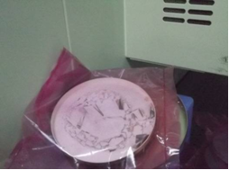 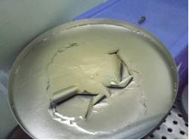  
        遮板NG圖 NG shutter  
       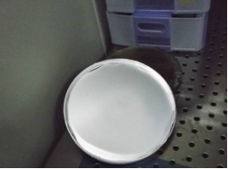  
        正常遮板 OK shutter
    2. OP每鍋蒸鍍前檢查加熱燈反射鏡與視窗玻璃是否霧化，如有，請自行更換  
       Before evaporation process start, check the heater mirror and the windows mirror. If the heater mirror and the windows mirror are not cleaning, change new one.   
       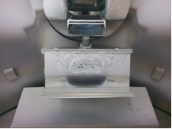

反射鏡NG圖 NG Type

* 1. 設備定期保養工作內容 Equipment regularly maintain：
     1. 蒸鍍機用之內襯每200±25 Run作更換。

Change baffle of evaporator every 200±25 runs.

* + 1. 每次機台及有更換內襯時，機台需作腔體校溫乙次。

Equipment needs to calibrate chamber temperature when the baffle has been replaced.

* + 1. 鋁蒸鍍機台每隔15±2Run需敲鋁一次，敲鋁時需注意機台空隙，以避免金屬碎屑掉入機台內造成損壞

Clean crucible every 15±2Run for AL evaporation machine. When Clean crucible, be careful metal scraps to avoid falling into machine to damage.

* + 1. 坩鍋清潔時機如下表 Crucible clean timing as shown table

|  |  |  |
| --- | --- | --- |
| 蒸鍍機  Machine | 鋁蒸鍍坩鍋清潔run數  Al evaporation clean timing | Ti/Ni/Ag蒸鍍坩鍋清潔run數  Ti/Ni/Ag evaporation clean timing |
| E-gun 1 | 15±2 run |  |
| E-gun 2 | 15±2 run |  |
| E-gun 3 | 15±2 run | 8±2 run |
| E-gun 4 | 15±2 run | 8±2 run |

* + - 1. 金屬塊更換時間如下**：**

The replacement time of metal bulk as following：

|  |  |
| --- | --- |
| 金屬  Metal | 更換頻率  Replacement time |
| 鋁  Al | 每30±5Run更換，Al#4每15±3run更換，若未達則每週更換  Replace every 30±5Run,Al#4 every 15±3 Run, if not reached, replacement once a week |
| 鋁矽  AlSi | 每15±3Run更換，若未達則每3日更換  Replace every 15±3Run, if not reached, replacement every 3 days |
| 鎳  Ni | 每30±5Run更換，若未達則每2週更換  Replace every 30±5Run, if not reached, replacement every 2 weeks |
| 鈦  Ti | 每30±5Run更換，若未達則每2週更換  Replace every 30±5Run, if not reached, replacement every 2 weeks |
| 金  Au | 外觀汙染則更換，並每個月通知工程確認外觀  Replace when appearance dirty.Call the engineer check appearance every month, |
| 鉻  Cr | 外觀汙染則更換，每3週確認外觀  Replace when appearance dirty.Call the engineer check appearance every 3 weeks |

* + - 1. 舊金屬錠由產線回收

The used metal bulk should be recycled by production staff.

若靶材長時間未作業且已達 更換頻率，則回收該靶材，並於下次作業時再重新更換新靶材進行作業即可

If the source has not been used for a long time and the replacement frequency has been reached, the source is recycled and replaced with a new one during the next operation.

金屬更換記錄請統一紀錄在金屬更換紀錄表中

Please record all metal exchange records in the metal exchange record form

* + 1. 金屬預熔操作方式Operation steps of metal pre-melting：
       1. 確認腔體內不可有晶片。

Confirm inside of chamber that has no wafer.

* + - 1. 可由手動方式預融或執行自動鍍膜程式

Pre-melting could be run by manually operated or auto evaporation

* + 1. 鋁蒸鍍機內襯及蒸鍍轉盤管理規定：

Administrative provisions of baffle and dome：

* + - 1. 內襯每隔200±25 Run進行噴砂一次，由設備工程師進行更換。

Baffle used 200±25 Run should be processed by sand blasting and changed by equipment engineer.

* + - 1. 更換內襯後需完成空鍍一次(可與預融同時進行)，才可開始作業

After baffle change should run empty evaporation first can run with pre-melting, and then start production by production staff.

* + - 1. 外送噴砂回廠時需檢查蒸鍍金屬物是否有去除，及包裝是否良好，若有蒸鍍機襯套因噴砂變形及變薄時更換新品

Baffle after sand blasting should check whether metal residue is removed or package is well. If find the baffle is out of shape or thin because of sand blasting, that will be changed new one.

* + - 1. 每組襯套需刻上編號，外送廠商噴砂及回廠時都需請廠商提供工件出貨明細供產線留存。

Every baffle should label the number.When sending the workpiece to the manufacturer for sandblasting and returning , the manufacturer must provide workpiece shipment details list for the production line to keep.

* + - 1. 回廠襯套需整齊放在暫存箱

Baffle sent back should place in holding box.

* + - 1. 襯套噴砂作業流程 baffle sand blasting treatment process：  
         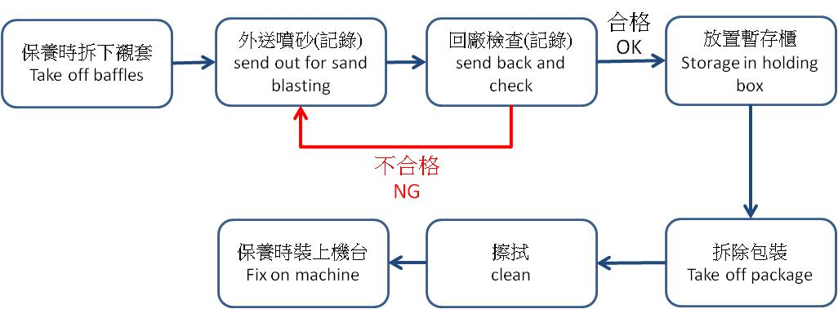
    1. 未使用之蒸鍍轉盤需放置在氮氣櫃保存，未使用和超過3天未使用之蒸鍍轉盤使用前要烘烤過75℃ 10分鐘(可用空鍍替代)才能作業

Dome without using should be storage in N2 box. If dome is not used exceed 3 days, that should oven 75℃ for 10min before using.

* + 1. 蒸鍍轉盤都要有刻號，並記錄使用於矽元件蒸鍍區使用記錄表

Label the number on dome, and record in Silicon Device evaporation record table

刻號label number for example:: E2 - 1 - 3

① ② ③

①:機台代號 machine symbol(E1、E2、E3、E4)

②:組數 set

③:轉盤編號 label number(1~3)

* + 1. 固定使用之蒸鍍轉盤每週至少噴砂一次，若蒸鍍轉盤每週使用均未超過5鍋，允一個月噴砂一次

Dome is usually used should treat with sand blasting every week. If dome run does not exceed 5 times in a week, allow sand blasting treatment once a month.

* + 1. 每次敲鋁後確認遮板與二極板間距是否>6mm，若>6mm則需進行調整 (E-4機台為固定位置除外)  
       Confirm the distance between shutter and diode plate is less than 6mm every crucible clean. If the distance is over 6mm, it must be revised. (E-4 machine is fixed position, not applicable.)
    2. 每次敲鋁完後，須請設備工程師確認遮板開合的角度，關閉時是否能完整附蓋蒸鍍源，打開時能否完整露出蒸鍍源。  
       After each Al tapping, the equipment engineer must confirm the movement angle of the shutter, whether the source can be completely covered when closed, and whether the source can be completely exposed when opened

1. 機台復機流程 Machine restart procedure
   1. 復機流程圖Flow chat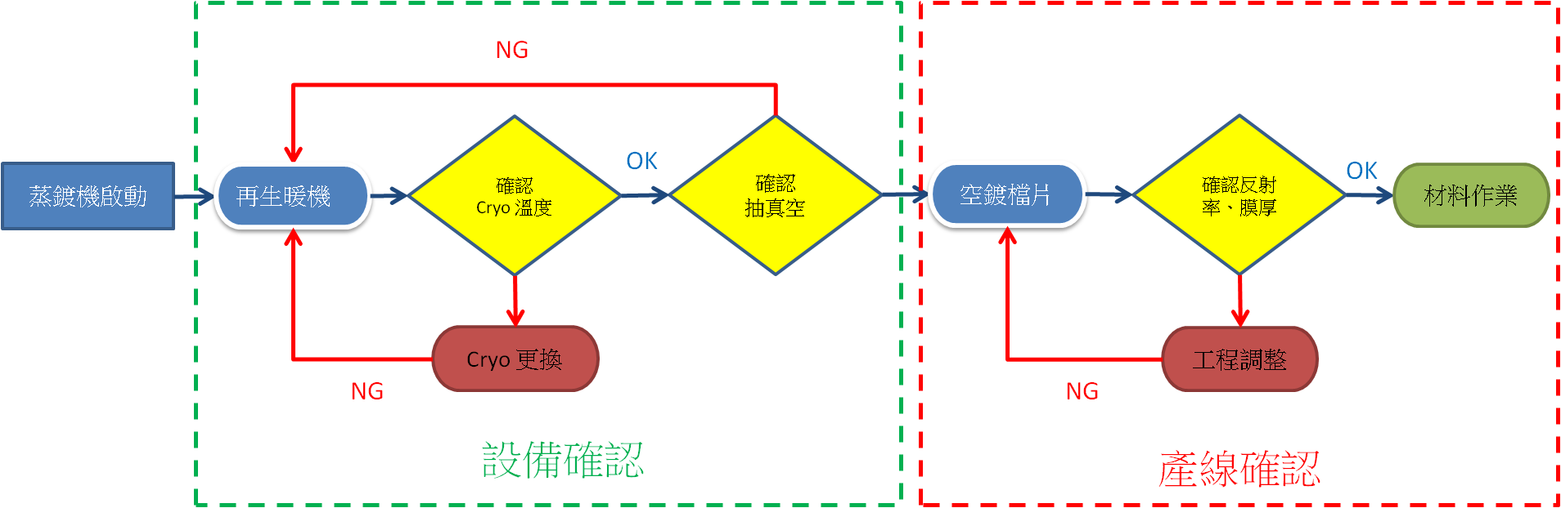
   2. 復機步驟與作業方式 restart step and operation method

|  |  |  |  |
| --- | --- | --- | --- |
| 機台  Machine | 程式 program | | |
| 步驟一:空鍍  Step 1: empty run | 步驟二:測跑程式  Step 2 : program trial run | 步驟三:產品測試  Step 3: product trial run |
| 鋁蒸鍍一  E-gun 1 | #50 AL 2K | #31 AL 13K, #35 AL 35K | 一般PD產品  Normal PD |
| 鋁蒸鍍二  E-gun 2 | #50 AL 2K | #31 AL 13K, #35 AL 35K | 一般PD產品  Normal PD |
| 鋁蒸鍍三  E-gun 3 | #50 AL 2K | #31 AL 13K, #35 AL 35K | 一般PD產品  Normal PD |
| 鋁蒸鍍四  E-gun 4 | #32 AL 2K | #9 AL 13K, #7 AL 35K | 一般PD產品  Normal PD |
| 管控項目  Monitor item | 抽真空時間  vacuum time | 抽真空時間、膜厚、反射率  vacuum time、thickness、reflectivity | 抽真空時間、膜厚 、反射率  vacuum time、thickness、reflectivity |

1. 使用表單 Table
   1. 矽元件蒸鍍區使用記錄表  
      Silicon Device evaporation record table (FM0901155)
   2. 溶液更換記錄表   
      Solution change record table (FMP020009)
   3. 反射率監控記錄表   
      Reflectivity record table (FMP020060)
   4. 蒸鍍區機台程式變更紀錄表   
      Evaporation program modify record table (FM090143-6)
   5. 矽元件3F蒸鍍前清洗蝕刻速率量測紀錄表 (FMP020104)
   6. 矽元件各班庫存金屬清點紀錄 (FM090167)  
      Inventory metal inventory record (FM090167)
   7. 溶液更換紀錄表 (FMP020009)  
      Melt replacement record sheet (FMP020009)
   8. 矽元件3樓無塵各班每日金屬使用量表(FMP020098)

3F daily metal usage table (FMP020098)

* 1. 金屬更換紀錄表(FMP020105)

metal exchange record form(FMP020105)

* 1. 蒸鍍擋片清洗記錄表Dummy of evaporation clean table (FMP020077)

1. 參考資料 Reference：
   1. CRTM- 7000、9100G蒸鍍控制器操作手冊 Evaporation controller operation manual
   2. MODE GI-TL3，GI-TL3RY離子真空計操作手冊Ionization vacuum meter operation manual
   3. MODEL EGL-35M電子槍操作手冊 E-gun controller operation manual
   4. MODEL HPS-1000S空冷式電子槍電源供應器操作手冊 Air cooling E-gun power supply system operation manual
   5. 油封式旋轉真空幫浦操作手冊Oil sealed vacuum pump operation manual
   6. 機械增壓幫浦操作手冊Dry pump operation manual
   7. WEST MODEL 8100溫度控制器操作手冊Heater controller operation manual
   8. 矽元件Detector鋁黑自主檢驗作業標準Silicon device dark pad independent inspection standards(SEG-5-034)

附件一 Annex I

鍍鋁流程圖flow chart of Al evaporation

不合格NG

通知課長

Notice leader

合格

結束 End

開始 Start

安裝晶片 Set wafer

洩真空 Vent

放置鋁錠，安置蒸鍍轉盤

Input Al and set dome

選取程式

Choose program

抽真空 Pump down

鍍鋁 Evaporate Al

冷卻 Cooling

記錄 Record

洩真空 Vent

取出蒸鍍轉盤 Replace 蒸鍍轉盤

測量鋁厚 Measure Al thickness